**Linux, Shell Scripting and Git Assignments**

Assignment 1: Initialize a new Git repository in a directory of your choice. Add a simple text file to the repository and make the first commit.

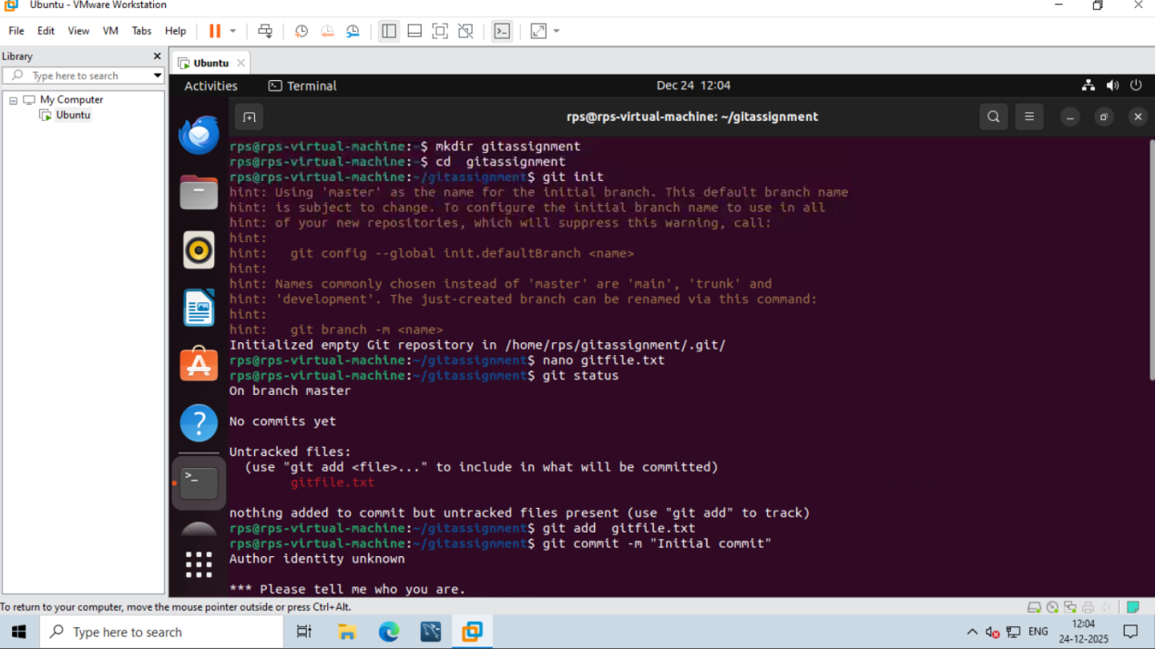

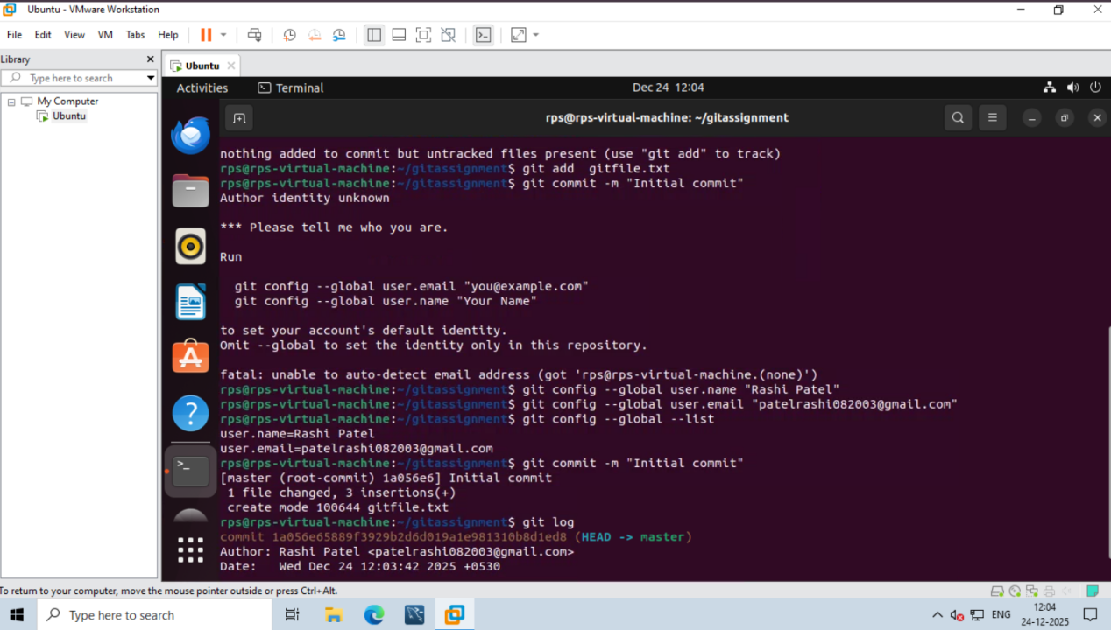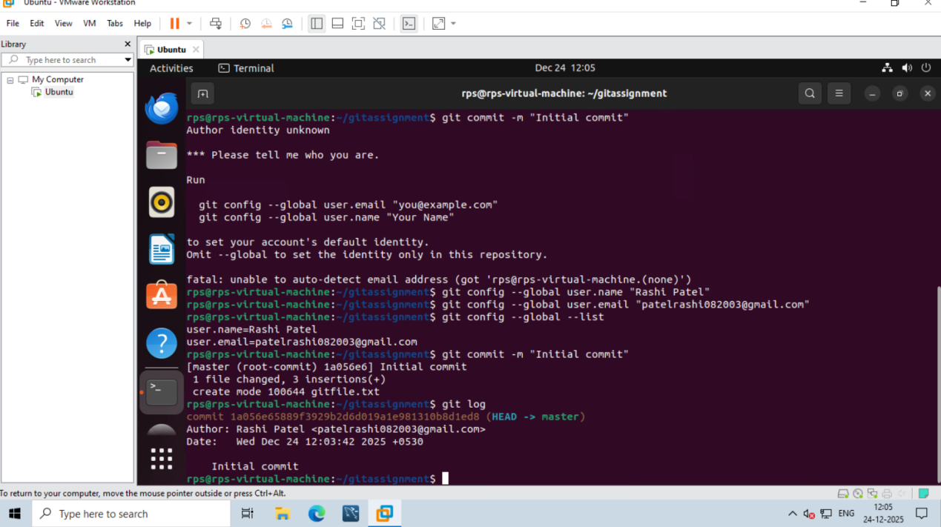

Assignment 2: Branch Creation and Switching

Create a new branch named 'feature' and switch to it. Make changes in the 'feature' branch and commit them.

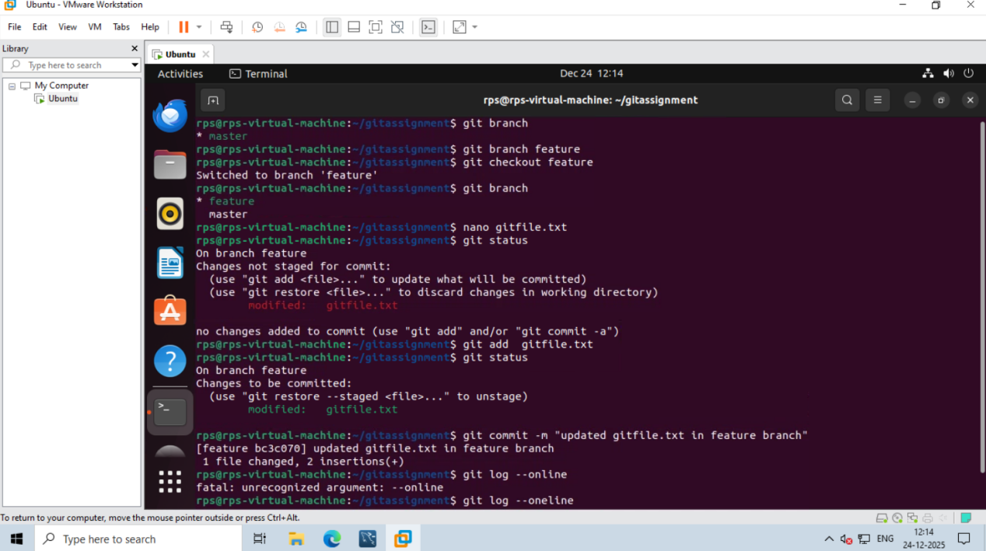

Assignment 3: Feature Branches and Hotfixes

Create a 'hotfix' branch to fix an issue in the main code. Merge the 'hotfix' branch into 'main' ensuring that the issue is resolved.

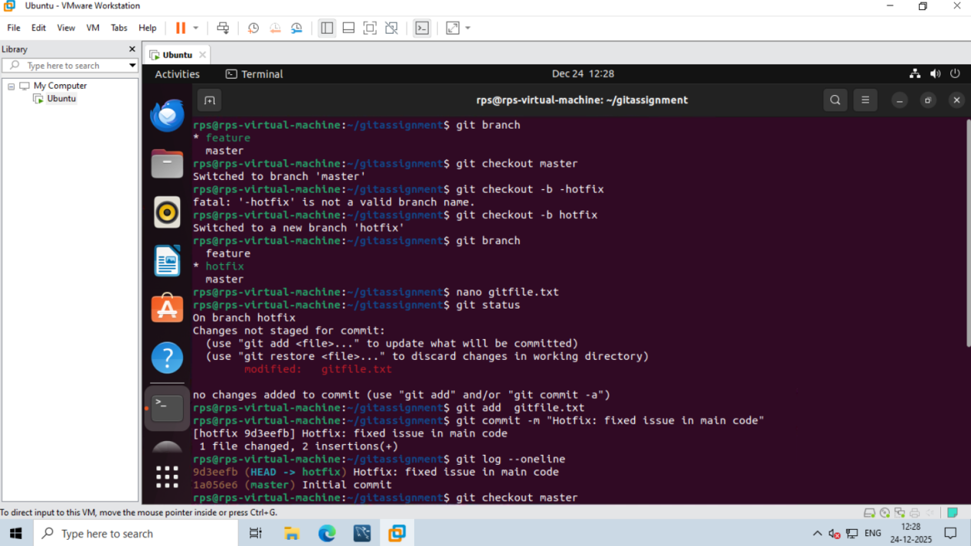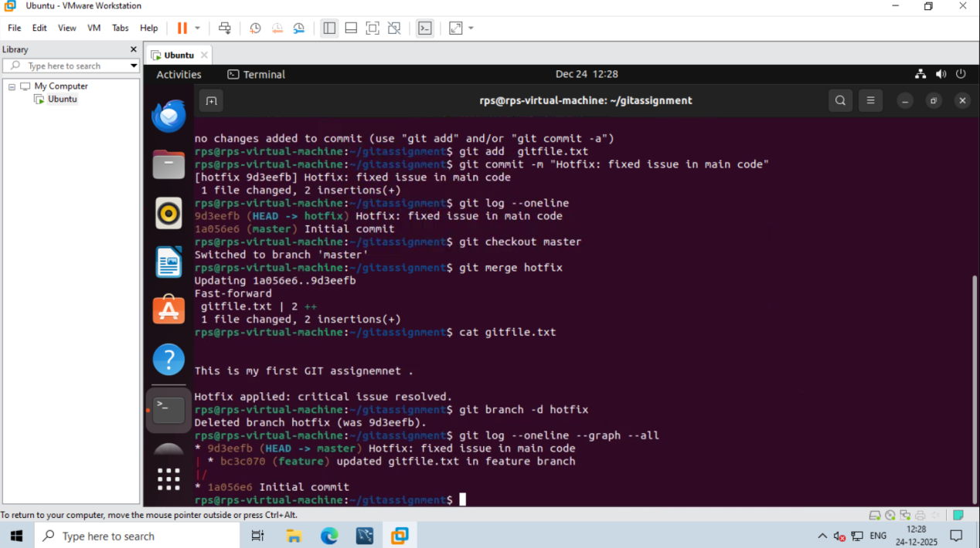

Assignment 1: Ensure the script checks if a specific file (e.g., myfile.txt) exists in the current directory. If it exists, print "File exists", otherwise print "File not found".

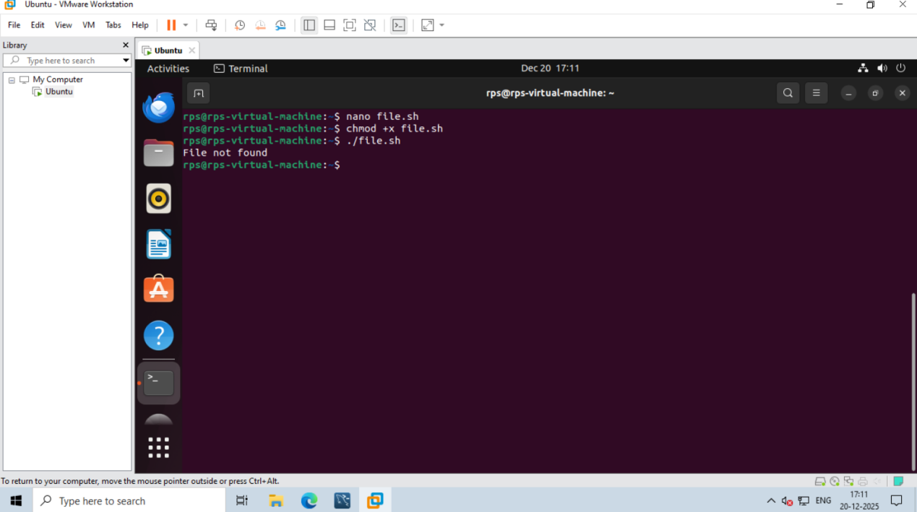

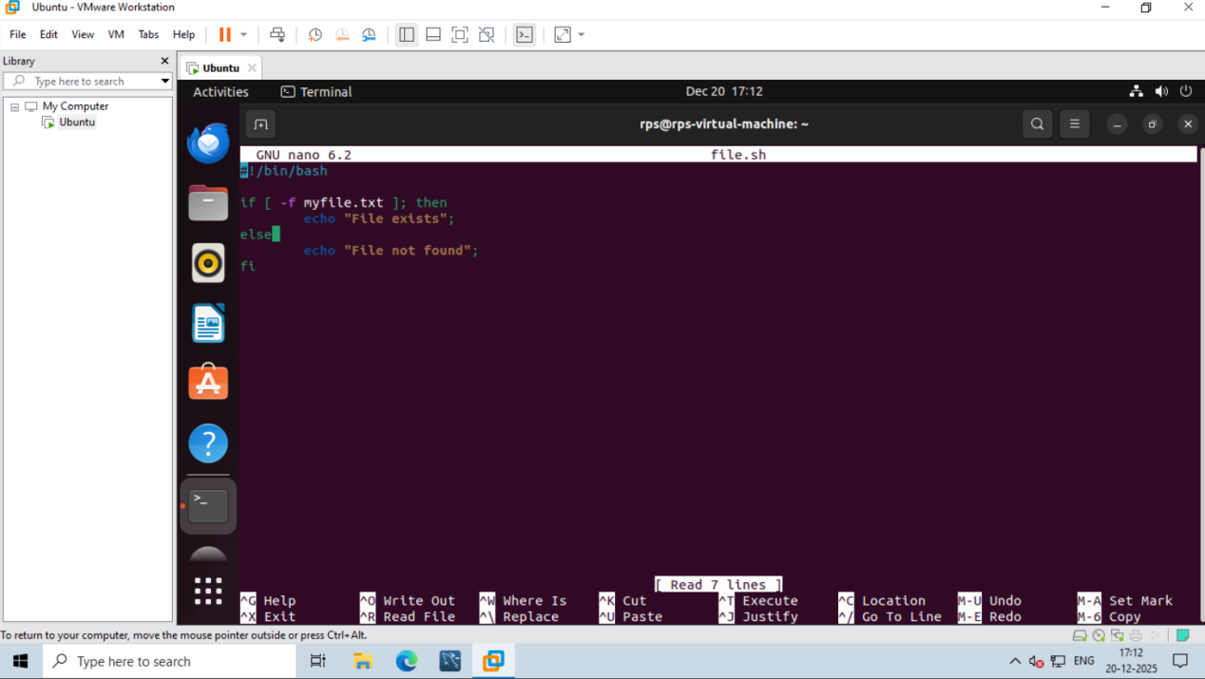

Assignment 2: Write a script that reads numbers from the user until they enter '0'. The script should also print whether each number is odd or even.

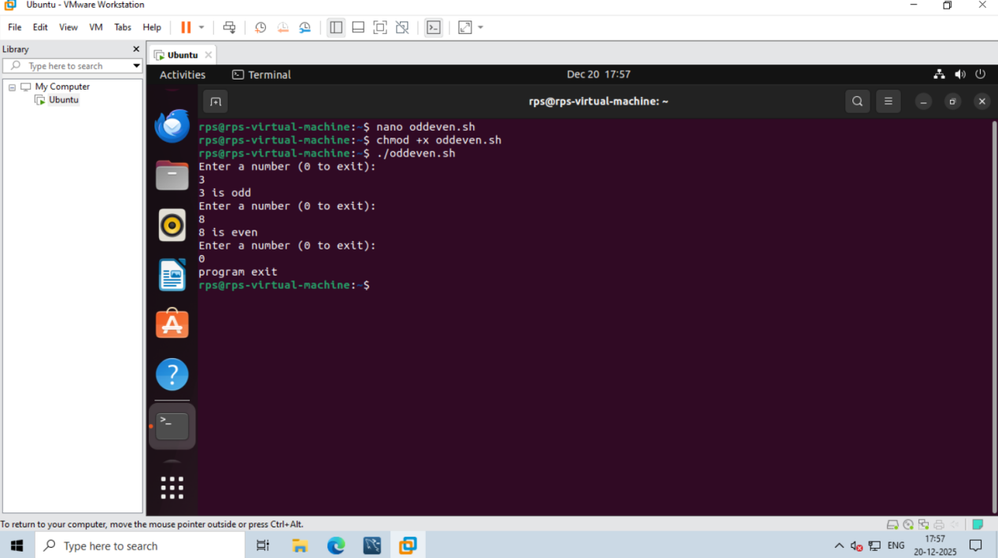

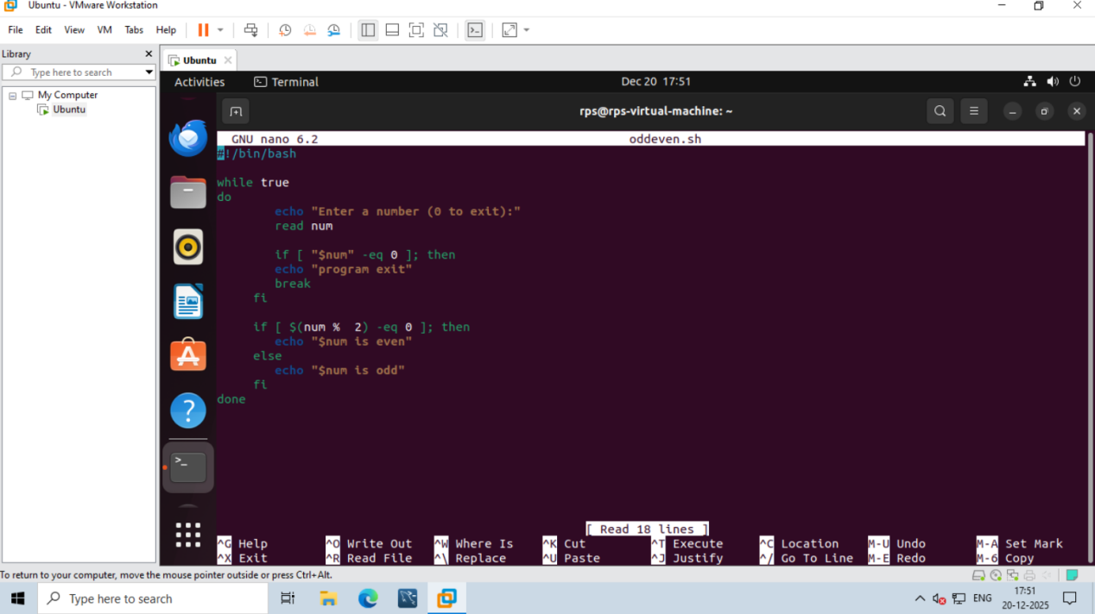

Assignment 3: Create a function that takes a filename as an argument and prints the number of lines in the file. Call this function from your script with different filenames.

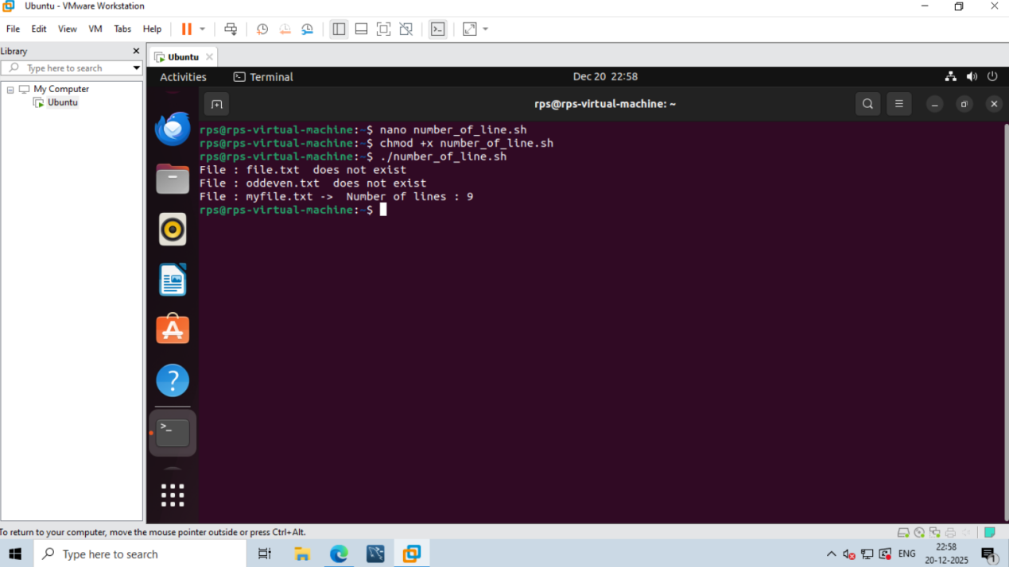

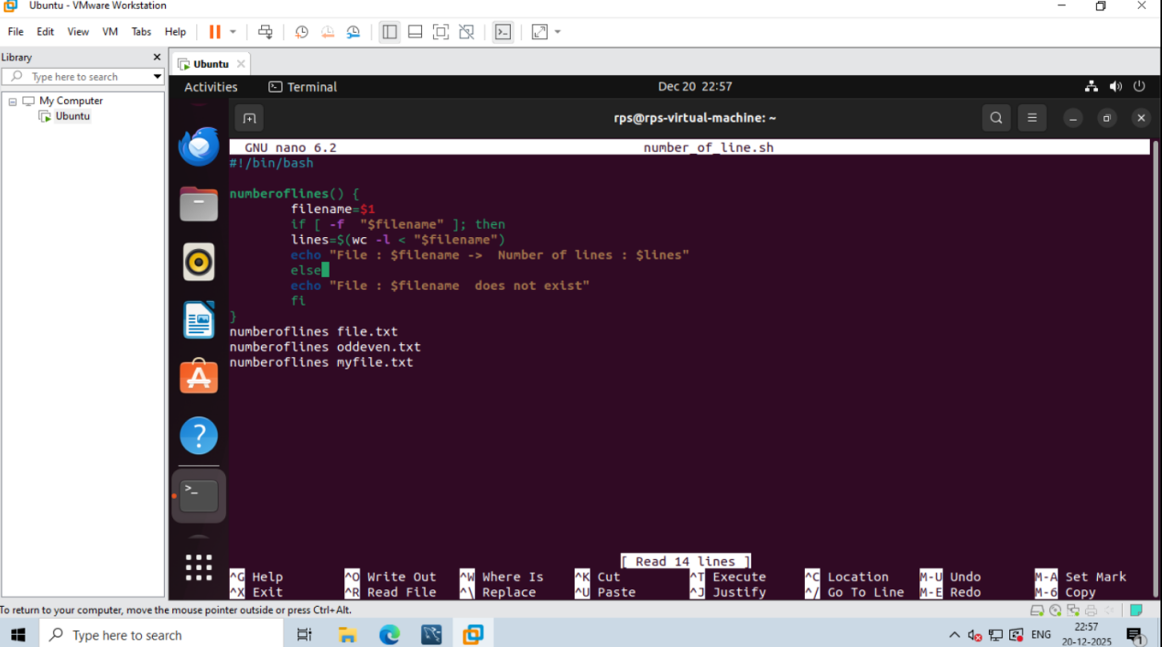

Assignment 4: Write a script that creates a directory named TestDir and inside it, creates ten files named File1.txt, File2.txt, ... File10.txt. Each file should contain its filename as its content (e.g., File1.txt contains "File1.txt").

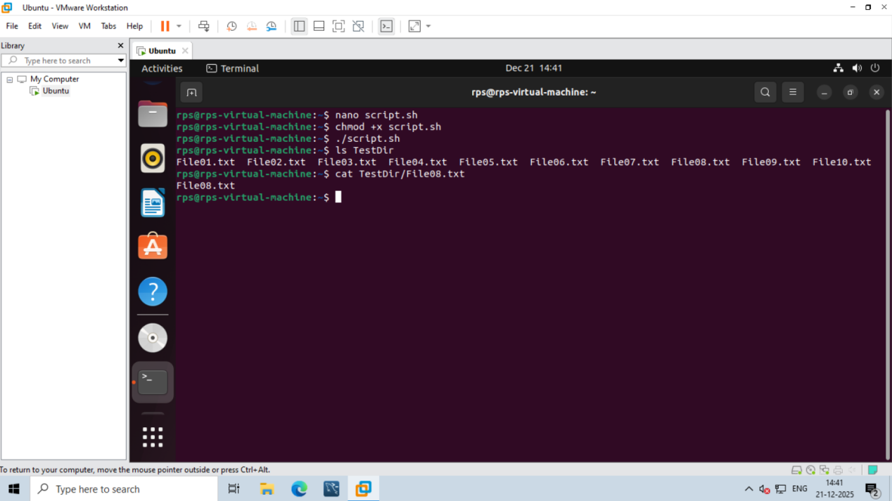

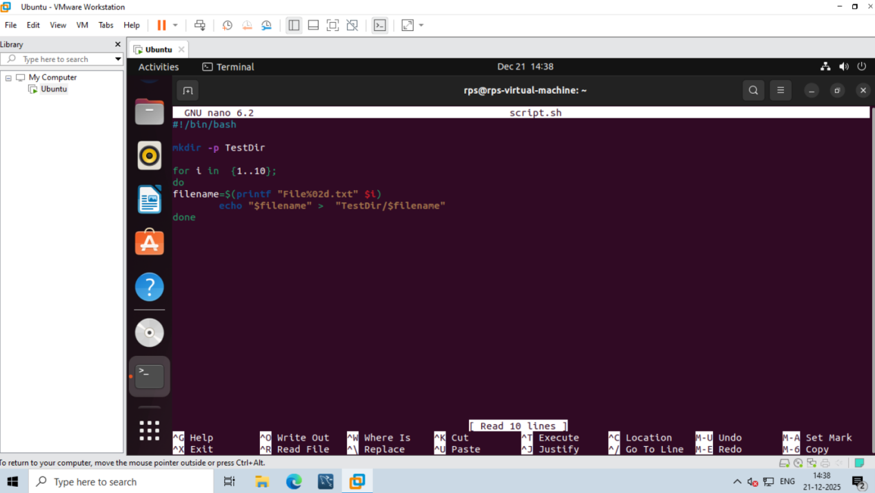

Assignment 5: Modify the script to handle errors, such as the directory already existing or lacking permissions to create files.Add a debugging mode that prints additional information when enabled.

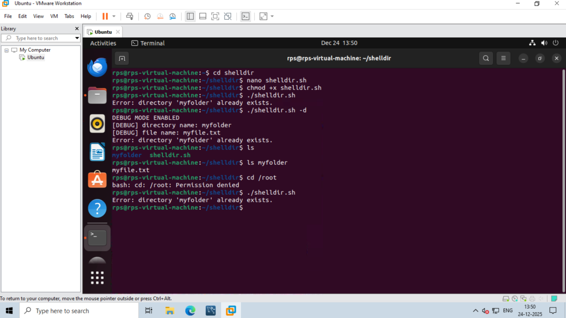

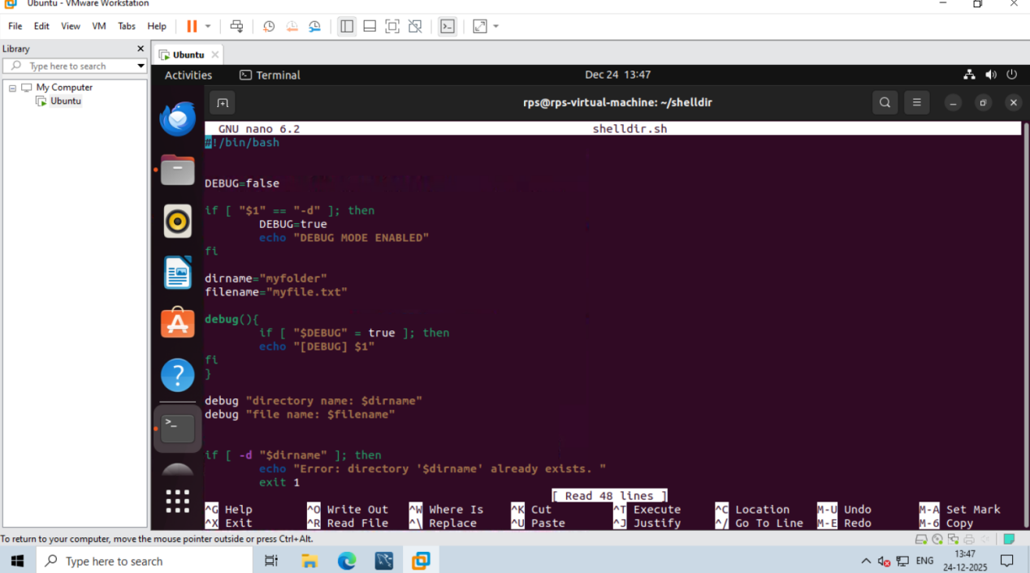

Assignment 6: Given a sample log file, write a script using grep to extract all lines containing "ERROR". Use awk to print the date, time, and error message of each extracted line.Data Processing with sed

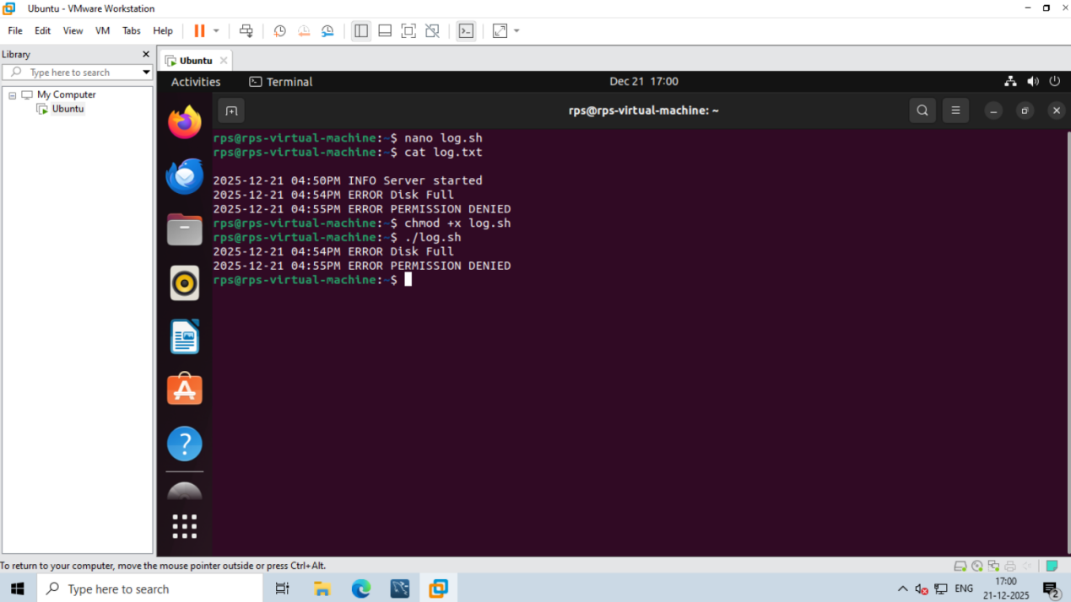

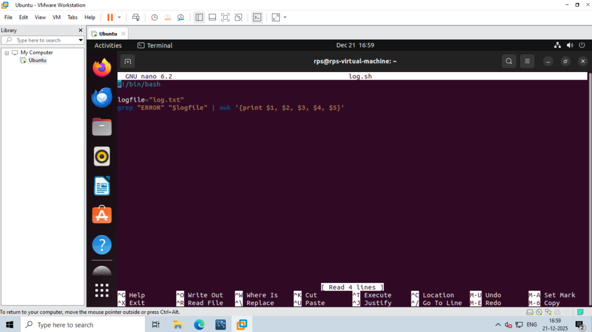

Assignment 7: Create a script that takes a text file and replaces all occurrences of "old_text" with "new_text". Use sed to perform this operation and output the result to a new file.

